AUCTION DONATION FORM | DEADLINE TO SUBMIT: 12/14/19

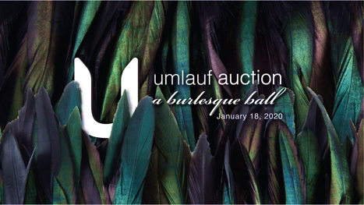

UMLAUF Auction: A Burlesque Ball
Saturday, January 18, 2020
7:00 – 11:00 p.m. at Sky Candy
1023 Springdale Road, Austin, TX 78721
www.umlaufsculpture.org/auction

Thank you for your support of the UMLAUF through your Auction Item Donation for A Burlesque Ball.

Donors to the Live and Silent Auction will be recognized in event displays and signage at A Burlesque Ball, as well as on the UMLAUF Auction webpage and promotional social media followed by 10,000+.

Donations valued at $2,500 or more entitles the donor to 2 GA Tickets for the UMLAUF’s Garden Party 2020.
Donations valued at $5,000 or more entitles the donor to 2 VIP Tickets for the UMLAUF’s Garden Party 2020.

DONOR INFORMATION

Name of Donor/Business ____________________________________________________________
As it should appear for recognition
Contact name: _____________________________________________________________________

Address: _________________________________________________________________________

Day Phone: ______________________ Email: _______________________________________

Description of Item for Donation
(for trips, tickets, hotels, vacation homes, etc: please include any restrictions, blackout or dates available):
___________________________________________________________________________________________

___________________________________________________________________________________

Fair Market Value $________________

❒ Items Enclosed
❒ Items to be delivered to the UMLAUF. To arrive BY JANUARY 4th, 2020
❒ Photo(s) of Item (can be sent as a .jpg file to email shown below). To arrive BY JANUARY 4th, 2020

Please return form, and/or item to:
UMLAUF Sculpture Garden + Museum
Attn: Dalya Sachs, Senior Development Manager
605 Azie Morton Road, Austin, TX 78704
510-919-4454 // dalya.sachs@umlaufsculpture.org

Thank you for your generous tax-deductible support!
All proceeds from the UMLAUF Auction benefit the UMLAUF Sculpture Garden and Museum, a 501c3 nonprofit.

